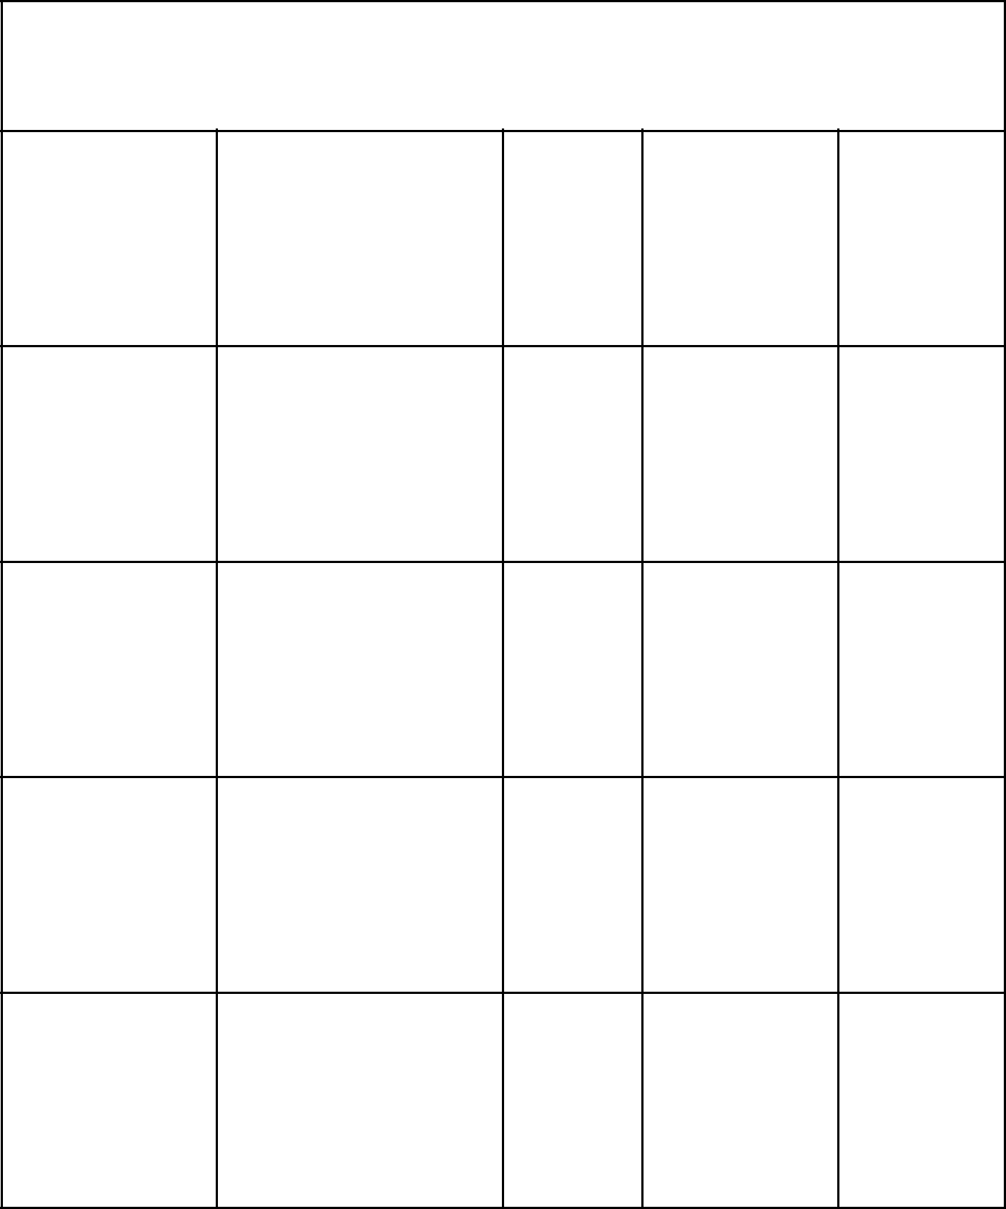**Schechter Experiences Bingo**

|  |  |  |  |  |
| --- | --- | --- | --- | --- |
| Basketball | Alternative Israel Science | Yom | Physics |  |
| Team | Ha’Zikaron |  |

Gym schechtermemes1 LA Specials Kehillah

|  |  |  |  |  |  |
| --- | --- | --- | --- | --- | --- |
| Nationalism | Chemistry | **FREE** | B’nai | Night |  |
| **Free** |  |
| Mitzvahs |  |
|  |  | **Space** |  |  |
|  |  |  |  |  |

|  |  |  |  |  |  |
| --- | --- | --- | --- | --- | --- |
|  | Chanukah | The |  | Touching |  |
| Kindergarten | Tribes | The |  |
| Assembly | Giver |  |
|  |  | Lights |  |
|  |  |  |  |  |

|  |  |  |  |  |  |
| --- | --- | --- | --- | --- | --- |
| 5th Grade | World Wars | Coach | Hebrew | Hot |  |
| Shabbaton | Doug | Lunch |  |
|  |  |  |



**Schechter Experiences Bingo**